实验3 Servlet
一．实验目的
掌握编写Servlet和两种配置方式，掌握使用Servlet实现接收请求参数，掌握Servlet的作用域和存取数据，掌握Servlet实现请求转发和重定向。
二. 实验环境
硬件：PC系列微机，CPU1.2G以上，内存512M以上
软件：Windows 11； chrome浏览器、JDK1.8、Eclipse Version: Oxygen.3a Release (4.7.3a)、Tomcat8.0.26、MySQL8.0等。
三. 实验内容
1、在集成开发软件中创建Java Web项目；在Java Web项目中创建一个TestServlet并使用web.xml配置；部署Java Web项目到Tomcat，测试访问TestServlet。
2、在集成开发软件中创建另一个Java Web项目；在该Java Web项目中创建TestServlet2并使用注解配置；部署Java Web项目到Tomcat，测试访问TestServlet2。
3、使用创建的第二个项目，编写InfoServlet接收用户注册信息，注册信息包括用户名、爱好（复选框）、性别（radio）。
4、使用创建的第二个项目，创建RequestScopeServlet并使用注解配置，在该Servlet中，创建Student对象，将Student对象分别保存到request、session、application作用域中；使用请求转发跳转到另一个Servlet ReceiveServlet，在ReceiveServlet中获取RequestScopeServlet中保存到request、session、application作用域的Student对象；部署Java Web项目到Tomcat，测试访问RequestScopeServlet。
5、修改4中的RequestScopeServlet，使用Servlet重定向跳转到另一个Servlet ReceiveServlet2，在ReceiveServlet2中尝试获取RequestScopeServlet中保存到request、session、application的Student对象；部署Java Web项目到Tomcat，测试访问RequestScopeServlet2。
四. 实验过程
- 在集成开发软件中创建Java Web项目；在Java Web项目中创建一个TestServlet并使用web.xml配置；部署Java Web项目到Tomcat，测试访问TestServlet。
代码：TestServlet.java
package servlet;

import java.io.IOException;
import javax.servlet.ServletException;
import javax.servlet.annotation.WebServlet;
import javax.servlet.http.HttpServlet;
import javax.servlet.http.HttpServletRequest;
import javax.servlet.http.HttpServletResponse;

/**
* Servlet implementation class TestServlet
*/
@WebServlet("/TestServlet")
public class TestServlet extends HttpServlet {
private static final long serialVersionUID = 1L;

/**
* @see HttpServlet#HttpServlet()
*/
public TestServlet() {
super();
// TODO Auto-generated constructor stub
}

/**
* @see HttpServlet#doGet(HttpServletRequest request, HttpServletResponse response)
*/
protected void doGet(HttpServletRequest request, HttpServletResponse response) throws ServletException, IOException {
// TODO Auto-generated method stub
response.getWriter().append("Served at: ").append(request.getContextPath());
}

/**
* @see HttpServlet#doPost(HttpServletRequest request, HttpServletResponse response)
*/
protected void doPost(HttpServletRequest request, HttpServletResponse response) throws ServletException, IOException {
// TODO Auto-generated method stub
doGet(request, response);
}
}
Web.xml截图：

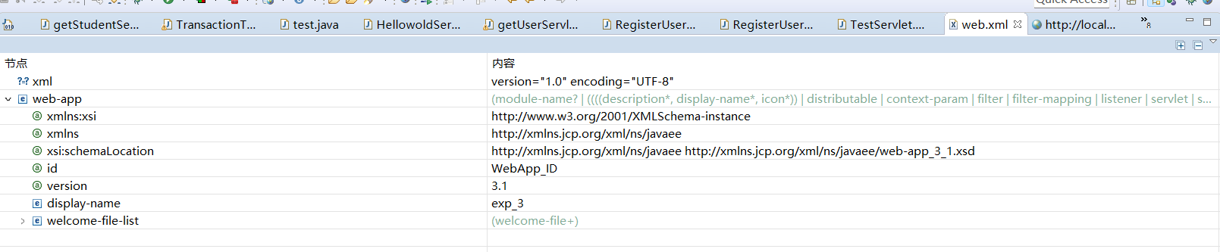
实现截图：
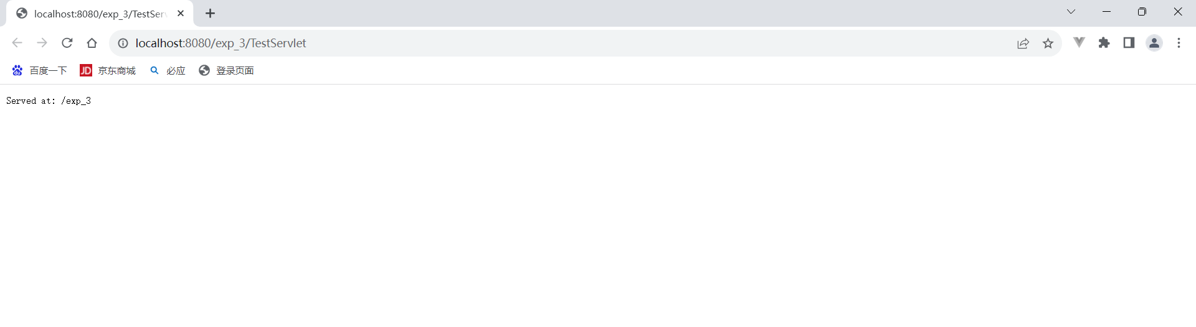
- 在集成开发软件中创建另一个Java Web项目；在该Java Web项目中创建TestServlet2并使用注解配置；部署Java Web项目到Tomcat，测试访问TestServlet2。
代码TestServlet2.java
package servlet;

import java.io.IOException;
import javax.servlet.ServletException;
import javax.servlet.annotation.WebServlet;
import javax.servlet.http.HttpServlet;
import javax.servlet.http.HttpServletRequest;
import javax.servlet.http.HttpServletResponse;

/**
* Servlet implementation class TestServlet2
*/
@WebServlet("/TestServlet2")
public class TestServlet2 extends HttpServlet {
private static final long serialVersionUID = 1L;

/**
* @see HttpServlet#HttpServlet()
*/
public TestServlet2() {
super();
// TODO Auto-generated constructor stub
}

/**
* @see HttpServlet#doGet(HttpServletRequest request, HttpServletResponse response)
*/
protected void doGet(HttpServletRequest request, HttpServletResponse response) throws ServletException, IOException {
// TODO Auto-generated method stub
response.getWriter().append("Served at: ").append(request.getContextPath());
}

/**
* @see HttpServlet#doPost(HttpServletRequest request, HttpServletResponse response)
*/
protected void doPost(HttpServletRequest request, HttpServletResponse response) throws ServletException, IOException {
// TODO Auto-generated method stub
doGet(request, response);
}}
运行成功截图：
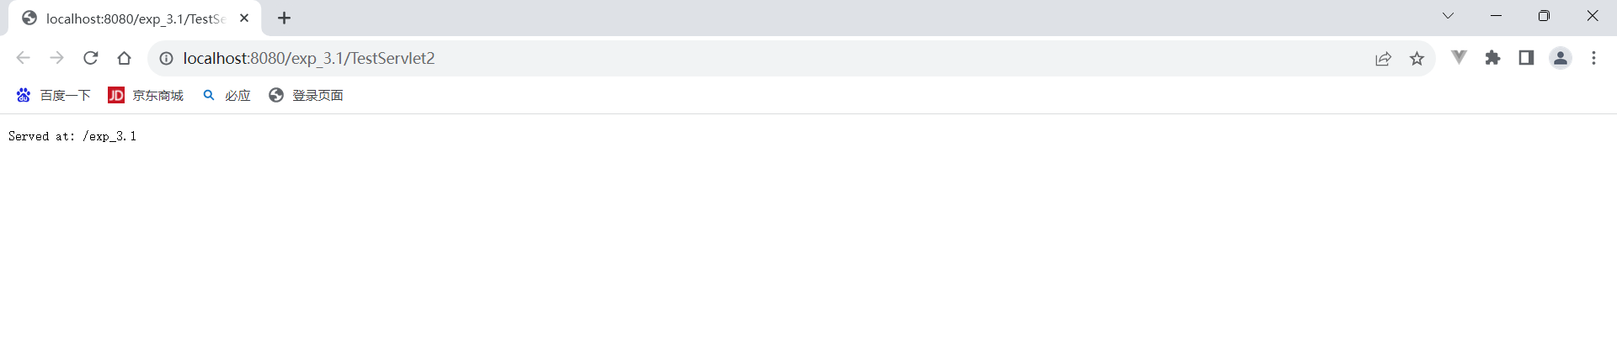
- 使用创建的第二个项目，编写InfoServlet接收用户注册信息，注册信息包括用户名、爱好（复选框）、性别（radio）。
代码InfoServlet.java
package servletExm1;

import java.io.IOException;
import java.util.Arrays;

import javax.servlet.ServletException;
import javax.servlet.annotation.WebServlet;
import javax.servlet.http.HttpServlet;
import javax.servlet.http.HttpServletRequest;
import javax.servlet.http.HttpServletResponse;

/**
* Servlet implementation class InfoServlet
*/
@WebServlet("/InfoServlet")
public class InfoServlet extends HttpServlet {
private static final long serialVersionUID = 1L;

/**
* @see HttpServlet#HttpServlet()
*/
public InfoServlet() {
super();
// TODO Auto-generated constructor stub
}

/**
* @see HttpServlet#doGet(HttpServletRequest request, HttpServletResponse response)
*/
protected void doGet(HttpServletRequest request, HttpServletResponse response) throws ServletException, IOException {
// TODO Auto-generated method stub
request.setCharacterEncoding("utf-8");
response.setCharacterEncoding("utf-8");

response.setContentType("text/html;charset=UTF-8");

String username = request.getParameter("username");
String[] hobbies = request.getParameterValues("hobby");
String gender = request.getParameter("gender");

request.setAttribute("username", username);
request.setAttribute("hobbies", Arrays.toString(hobbies));
request.setAttribute("gender", gender);

request.getRequestDispatcher("register.jsp").forward(request, response);
}

/**
* @see HttpServlet#doPost(HttpServletRequest request, HttpServletResponse response)
*/
protected void doPost(HttpServletRequest request, HttpServletResponse response) throws ServletException, IOException {
// TODO Auto-generated method stub
doGet(request, response);
}
}
Register.jsp页面
<%@ page language="java" contentType="text/html; charset=utf-8"
pageEncoding="utf-8"%>
<!DOCTYPE html PUBLIC "-//W3C//DTD HTML 4.01 Transitional//EN" "http://www.w3.org/TR/html4/loose.dtd">
<html>
<head>
<meta http-equiv="Content-Type" content="text/html; charset=utf-8">
<title>登陆窗口</title>
</head>
<body>
<form action="InfoServlet" method="POST">
<label for="username">用户名</label>
<input type="text" name="username" id="username" checked><br><br>

<label for="hobby">爱好:</label><br>
<input type="checkbox" name="hobby" value="阅读">阅读<br>
<input type="checkbox" name="hobby" value="运动">运动<br>
<input type="checkbox" name="hobby" value="音乐">音乐<br><br>

<label for="gender">性别:</label><br>
<input type="radio" name="gender" value="男">男<br>
<input type="radio" name="gender" value="女">女<br><br>

<input type="submit" value="提交">
</form>

<%-- 显示已注册的信息 --%>
<p>用户名: ${username}</p>
<p>爱好: ${hobbies}</p>
<p>性别: ${gender}</p>
</body>
</html>
运行截图：
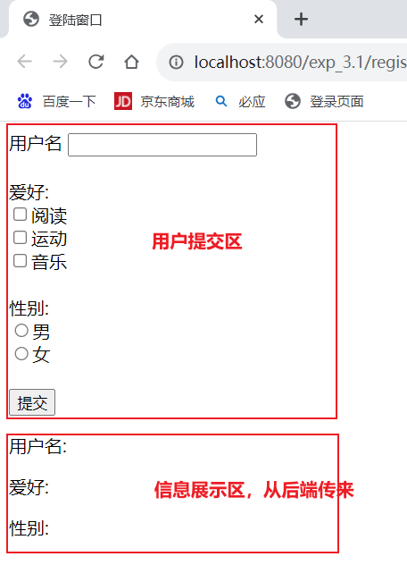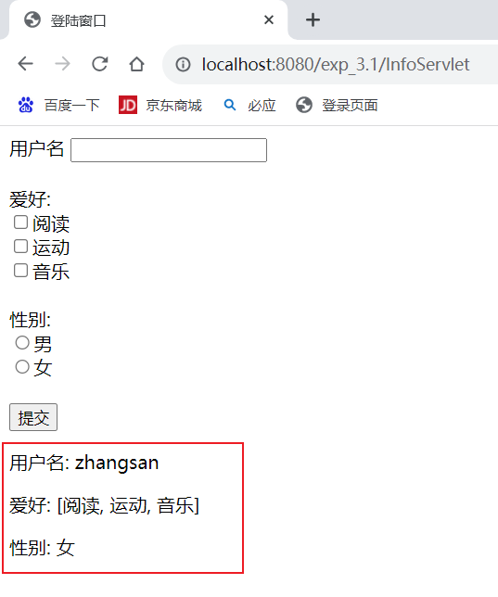

- 使用创建的第二个项目，创建RequestScopeServlet并使用注解配置，在该Servlet中，创建Student对象，将Student对象分别保存到request、session、application作用域中；使用请求转发跳转到另一个Servlet ReceiveServlet，在ReceiveServlet中获取RequestScopeServlet中保存到request、session、application作用域的Student对象；部署Java Web项目到Tomcat，测试访问RequestScopeServlet。
- Request
RequestScopeServlet.java
package servlet;

import java.io.IOException;
import javax.servlet.ServletException;
import javax.servlet.annotation.WebServlet;
import javax.servlet.http.HttpServlet;
import javax.servlet.http.HttpServletRequest;
import javax.servlet.http.HttpServletResponse;

/**
* Servlet implementation class RequestScopeServlet
*/
@WebServlet("/RequestScopeServlet")
public class RequestScopeServlet extends HttpServlet {
private static final long serialVersionUID = 1L;

/**
* @see HttpServlet#HttpServlet()
*/
public RequestScopeServlet() {
super();
// TODO Auto-generated constructor stub
}

/**
* @see HttpServlet#doGet(HttpServletRequest request, HttpServletResponse response)
*/
protected void doGet(HttpServletRequest request, HttpServletResponse response) throws ServletException, IOException {
// TODO Auto-generated method stub
Student student=new Student("zhangsan",123);
request.setAttribute("student", student);
request.getRequestDispatcher("receiveServlet").forward(request, response);
}

/**
* @see HttpServlet#doPost(HttpServletRequest request, HttpServletResponse response)
*/
protected void doPost(HttpServletRequest request, HttpServletResponse response) throws ServletException, IOException {
// TODO Auto-generated method stub
doGet(request, response);
}
}
ReceiveServlet.java
package servlet;

import java.io.IOException;
import java.io.PrintWriter;

import javax.servlet.ServletException;
import javax.servlet.annotation.WebServlet;
import javax.servlet.http.HttpServlet;
import javax.servlet.http.HttpServletRequest;
import javax.servlet.http.HttpServletResponse;

/**
* Servlet implementation class receiveServlet
*/
@WebServlet("/receiveServlet")
public class receiveServlet extends HttpServlet {
private static final long serialVersionUID = 1L;

/**
* @see HttpServlet#HttpServlet()
*/
public receiveServlet() {
super();
// TODO Auto-generated constructor stub
}

/**
* @see HttpServlet#doGet(HttpServletRequest request, HttpServletResponse response)
*/
protected void doGet(HttpServletRequest request, HttpServletResponse response) throws ServletException, IOException {
// TODO Auto-generated method stub
PrintWriter out= response.getWriter();
Student student=(Student) request.getAttribute("student");
out.println(student.getSno());
}

/**
* @see HttpServlet#doPost(HttpServletRequest request, HttpServletResponse response)
*/
protected void doPost(HttpServletRequest request, HttpServletResponse response) throws ServletException, IOException {
// TODO Auto-generated method stub
doGet(request, response);
}}
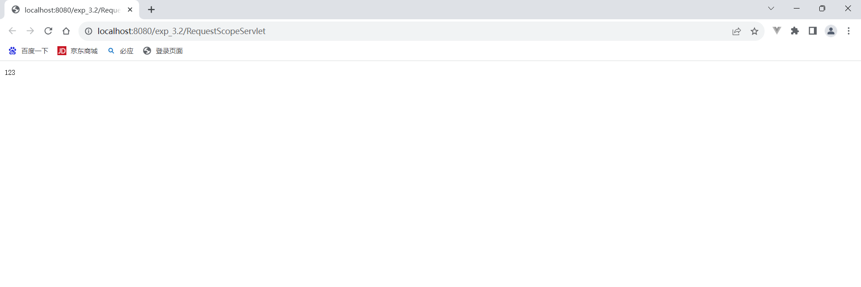
- Session
SessionReceiveServlet.java
package servlet;

import java.io.IOException;
import java.io.PrintWriter;

import javax.servlet.ServletException;
import javax.servlet.annotation.WebServlet;
import javax.servlet.http.HttpServlet;
import javax.servlet.http.HttpServletRequest;
import javax.servlet.http.HttpServletResponse;
import javax.servlet.http.HttpSession;

/**
* Servlet implementation class SessionReceiveServlet
*/
@WebServlet("/SessionReceiveServlet")
public class SessionReceiveServlet extends HttpServlet {
private static final long serialVersionUID = 1L;

/**
* @see HttpServlet#HttpServlet()
*/
public SessionReceiveServlet() {
super();
// TODO Auto-generated constructor stub
}

/**
* @see HttpServlet#doGet(HttpServletRequest request, HttpServletResponse response)
*/
protected void doGet(HttpServletRequest request, HttpServletResponse response) throws ServletException, IOException {
// TODO Auto-generated method stub
PrintWriter out= response.getWriter();
HttpSession session=request.getSession();
Student student=(Student) session.getAttribute("student");
out.println(student.getSno());
}

/**
* @see HttpServlet#doPost(HttpServletRequest request, HttpServletResponse response)
*/
protected void doPost(HttpServletRequest request, HttpServletResponse response) throws ServletException, IOException {
// TODO Auto-generated method stub
doGet(request, response);
}}
SessionScopeServlet.java
package servlet;

import java.io.IOException;
import javax.servlet.ServletException;
import javax.servlet.annotation.WebServlet;
import javax.servlet.http.HttpServlet;
import javax.servlet.http.HttpServletRequest;
import javax.servlet.http.HttpServletResponse;
import javax.servlet.http.HttpSession;

/**
* Servlet implementation class SessionScopeServlet
*/
@WebServlet("/SessionScopeServlet")
public class SessionScopeServlet extends HttpServlet {
private static final long serialVersionUID = 1L;

/**
* @see HttpServlet#HttpServlet()
*/
public SessionScopeServlet() {
super();
// TODO Auto-generated constructor stub
}

/**
* @see HttpServlet#doGet(HttpServletRequest request, HttpServletResponse response)
*/
protected void doGet(HttpServletRequest request, HttpServletResponse response) throws ServletException, IOException {
// TODO Auto-generated method stub
Student student=new Student("zhangsan",4567);
HttpSession session=request.getSession();
session.setAttribute("student", student);
}

/**
* @see HttpServlet#doPost(HttpServletRequest request, HttpServletResponse response)
*/
protected void doPost(HttpServletRequest request, HttpServletResponse response) throws ServletException, IOException {
// TODO Auto-generated method stub
doGet(request, response);
}
}
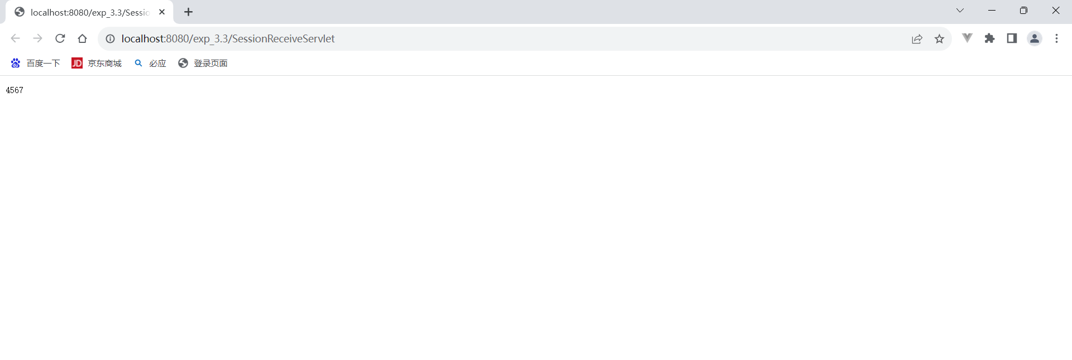
- Application
ApplicationScopeServlet.java
package servlet;

import java.io.IOException;
import java.io.PrintWriter;

import javax.servlet.ServletContext;
import javax.servlet.ServletException;
import javax.servlet.annotation.WebServlet;
import javax.servlet.http.HttpServlet;
import javax.servlet.http.HttpServletRequest;
import javax.servlet.http.HttpServletResponse;

import bean.User;

/**
* Servlet implementation class ReceiveServlet
*/
@WebServlet("/ApplicationScopeServlet")
public class ApplicationScopeServlet extends HttpServlet {
private static final long serialVersionUID = 1L;

/**
* @see HttpServlet#HttpServlet()
*/
public ApplicationScopeServlet() {
super();
// TODO Auto-generated constructor stub
}

/**
* @see HttpServlet#doGet(HttpServletRequest request, HttpServletResponse response)
*/
protected void doGet(HttpServletRequest request, HttpServletResponse response) throws ServletException, IOException {
// TODO Auto-generated method stub
User user=new User("zhangsan","7891112");
ServletContext application=this.getServletContext();
application.setAttribute("user", user);

}

/**
* @see HttpServlet#doPost(HttpServletRequest request, HttpServletResponse response)
*/
protected void doPost(HttpServletRequest request, HttpServletResponse response) throws ServletException, IOException {
// TODO Auto-generated method stub
doGet(request, response);

}

}

ApplicationReceiveServlet.java
package servlet;

import java.io.IOException;
import java.io.PrintWriter;

import javax.servlet.ServletContext;
import javax.servlet.ServletException;
import javax.servlet.annotation.WebServlet;
import javax.servlet.http.HttpServlet;
import javax.servlet.http.HttpServletRequest;
import javax.servlet.http.HttpServletResponse;

import bean.User;

/**
* Servlet implementation class ReceiveServlet
*/
@WebServlet("/ApplicationReceiveServlet")
public class ApplicationReceiveServlet extends HttpServlet {
private static final long serialVersionUID = 1L;

/**
* @see HttpServlet#HttpServlet()
*/
public ApplicationReceiveServlet() {
super();
// TODO Auto-generated constructor stub
}

/**
* @see HttpServlet#doGet(HttpServletRequest request, HttpServletResponse response)
*/
protected void doGet(HttpServletRequest request, HttpServletResponse response) throws ServletException, IOException {
// TODO Auto-generated method stub
PrintWriter out= response.getWriter();
ServletContext application=this.getServletContext();
User user=(User) application.getAttribute("user");
out.println(user.getPassword());
}

/**
* @see HttpServlet#doPost(HttpServletRequest request, HttpServletResponse response)
*/
protected void doPost(HttpServletRequest request, HttpServletResponse response) throws ServletException, IOException {
// TODO Auto-generated method stub
doGet(request, response);

}
}
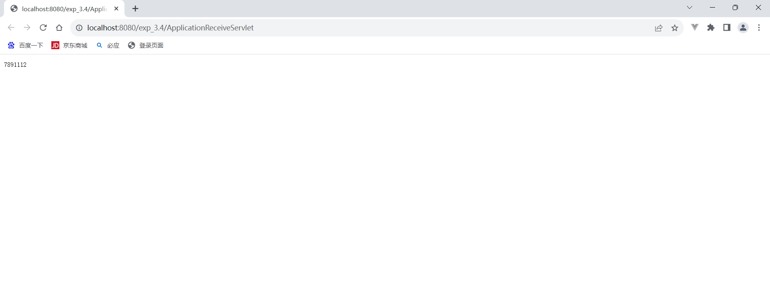
- 修改4中的RequestScopeServlet，使用Servlet重定向跳转到另一个Servlet ReceiveServlet2，在ReceiveServlet2中尝试获取RequestScopeServlet中保存到request、session、application的Student对象；部署Java Web项目到Tomcat，测试访问RequestScopeServlet2。
- request
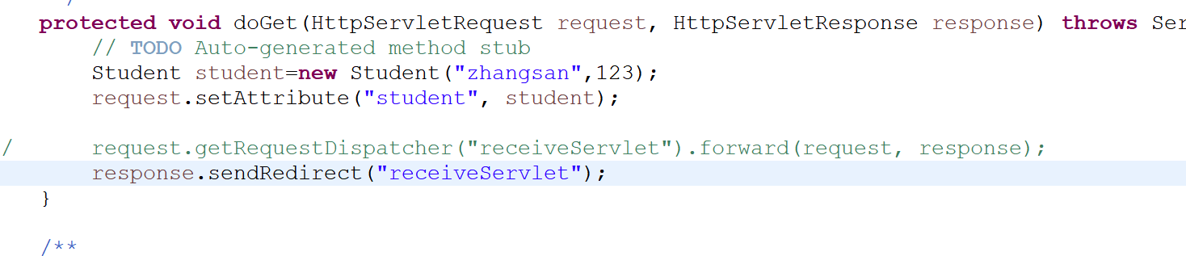
使用请求转发跳转
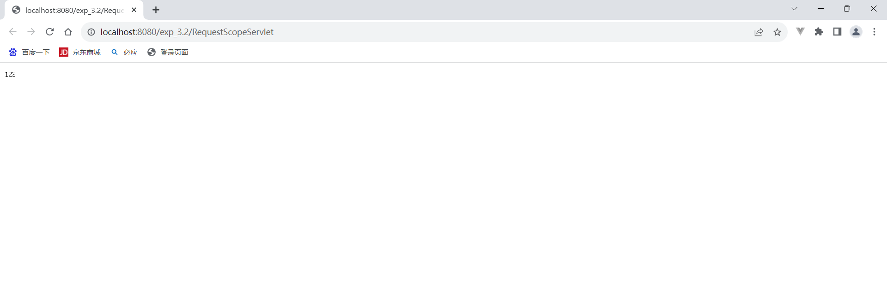
使用重定向跳转
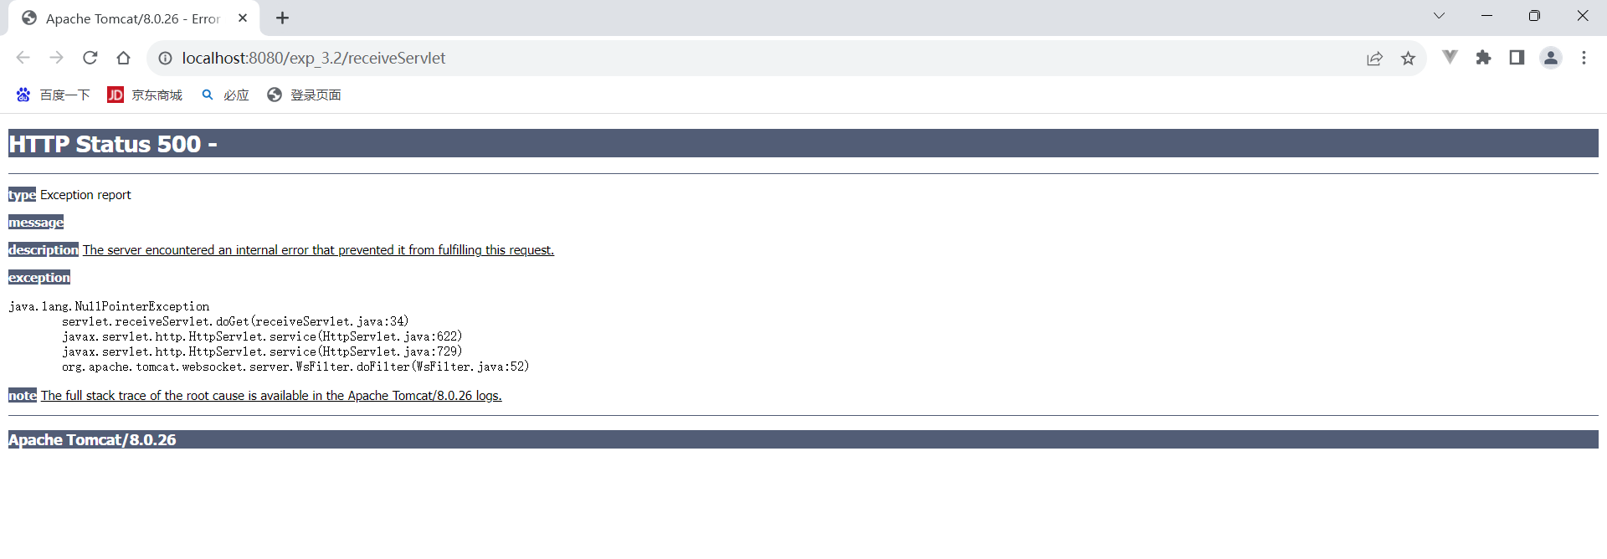
- Session
使用请求转发跳转
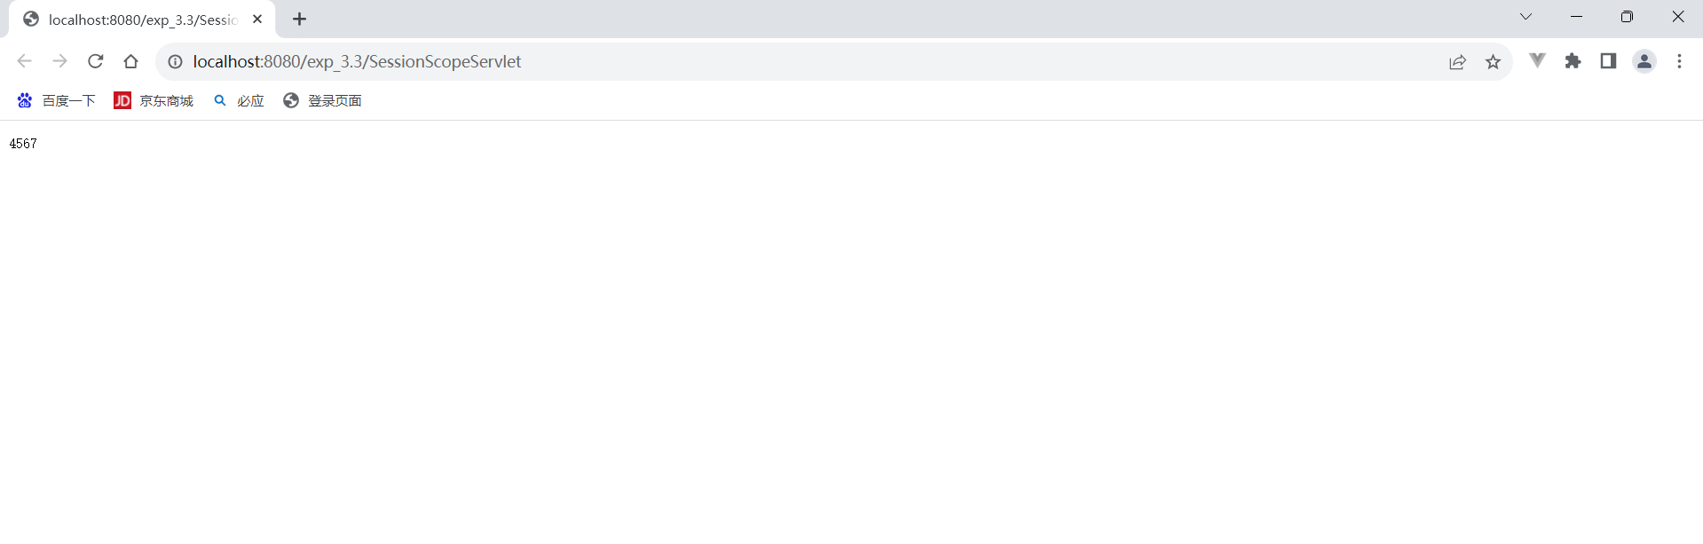
使用重定向跳转
- Application
使用请求转发跳转
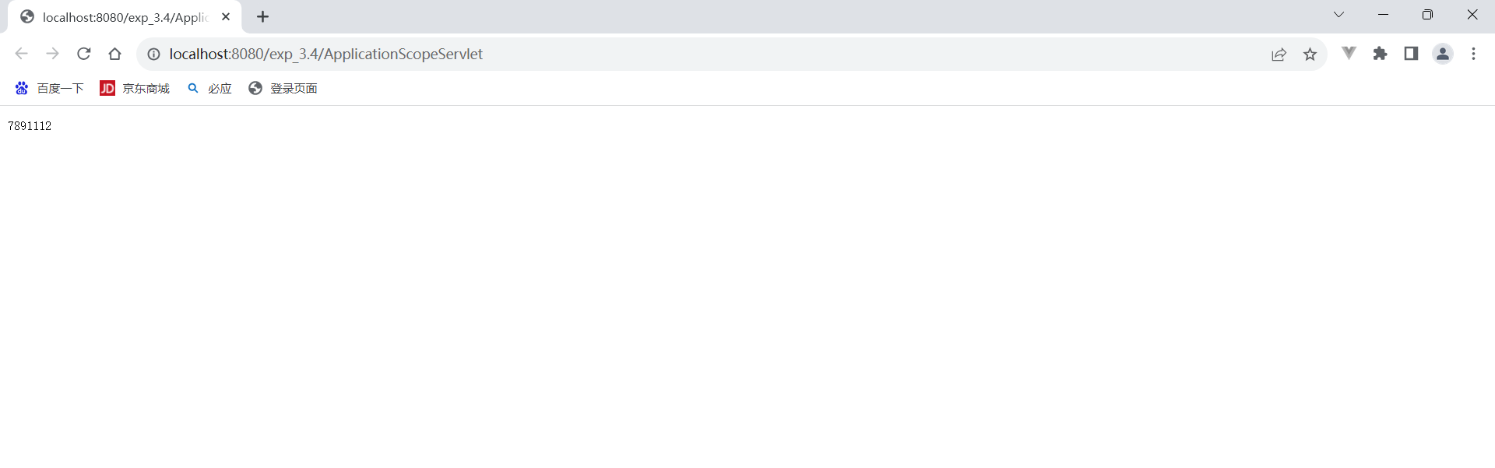
使用重定向跳转

实验内容5中运行结果差异的原因。
在request中，请求转发跳转带着数据转发跳转到另一个Servlet ReceiveServlet；重定向跳转是不带数据的重定向跳转到另一个Servlet ReceiveServlet，无法调用Student.getSno（），因此报错。
但是在session、Application中，请求转发跳转和重定向跳转都可以携带数据进行跳转。
五、实验总结
1.写出本次实验中遇到的主要问题。
- 在配置Servlet时，可能会遇到各种问题，如web.xml文件的配置错误。
- 出现乱码。
- 实现的具体函数不会用，没有记住。
2.解决方案
- 重新建立一个web动态文件项目即可。
- 规定utf-8编码即可显示正常。
- 查课本，查找课本示例代码。
- 明白了在request中重定向转发不能携带数据进行转发。

